|  |  |
| --- | --- |
| National Clothing Chain Summary Report |  |

# Project Name: Market Analysis Report for National Clothing Chain

This summary report deals with the Sales trends of National Clothing Chain. It entails a scientific data backed study from the company information and other related sources including external websites.

Analysis Questions and Responses:

1. What is the correlation (R2 value) between sales and income?

The correlation (R2 value) between sales and income is 0.88 and is a positive one. This is a strong correlation and the predictions are far more accurate.

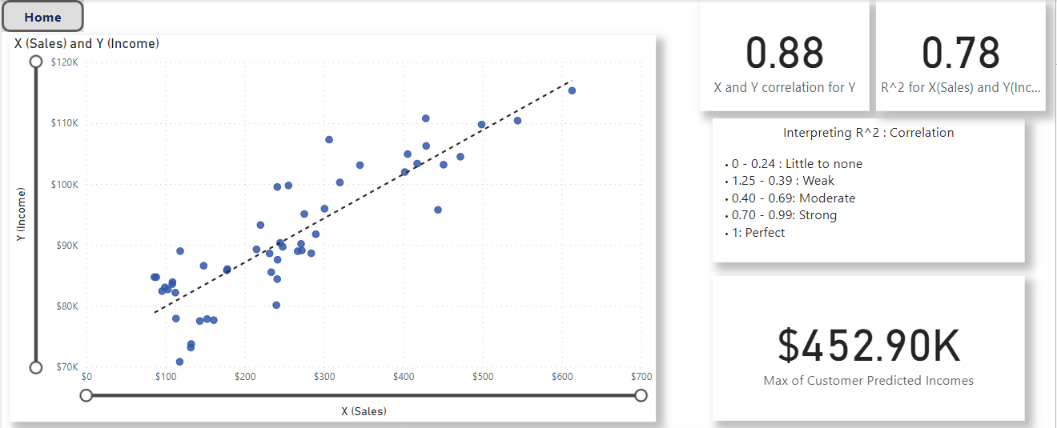

1. What is the correlation (R2 value) between customer ratings and product return rate?

The correlation (R2 value) between customer ratings and product return rate is 0.69 and is negative. This falls under the moderate category.

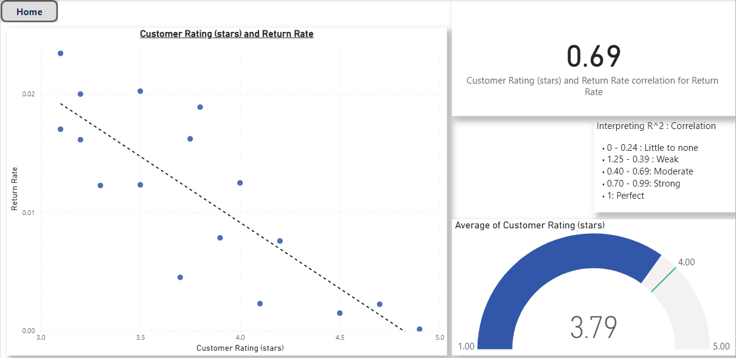

1. What are the linear regression formulas to predict customer sales and customer incomes?

The linear regression formulas are as follows:-

**Sales Prediction**

Final Formula for Sales Prediction = "X (Sales)=" & ROUND([b],2) & "-Y (Income)/-" & ROUND([m],2)

X (Sales) = 72639.72 – Y (Income)/-72.43

**Income Prediction**

Final Formula for Income Prediction = "Y (Income)=" & ROUND([m],2) & "x (Sales)+" & ROUND([b],2)

Y (Income) = 72.43x (Sales) + 72639.72

1. Which customer do you predict has the highest income?

Jon Little is being predicted with the highest income of $ 4,52,897.22.

1. Which product will be advertised the most?

Spring T-Shirt will be advertised the most.

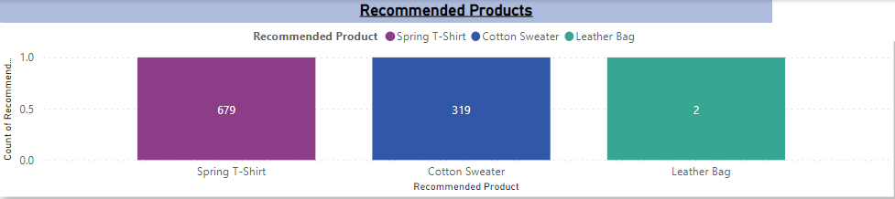

There are states with disproportionately large customer base when compared to the population. This was arrived by importing Outside data from web page *https://en.wikipedia.org/wiki/List_of_U.S._states_and_territories_by_population (*Source Wikipedia) and necessary steps were applied to it. The page “Untapped Markets” findings are as follows-

* 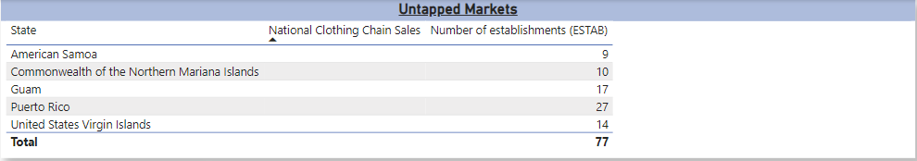There are 5 locations where National Clothing Chain needs to have presence
* The Population Vs Sales table shows the sales numbers vis a vis the populations of that state. States such as Texax, Florida, North Carolina etc. though on a higher side of population the sales numbers are considerably low

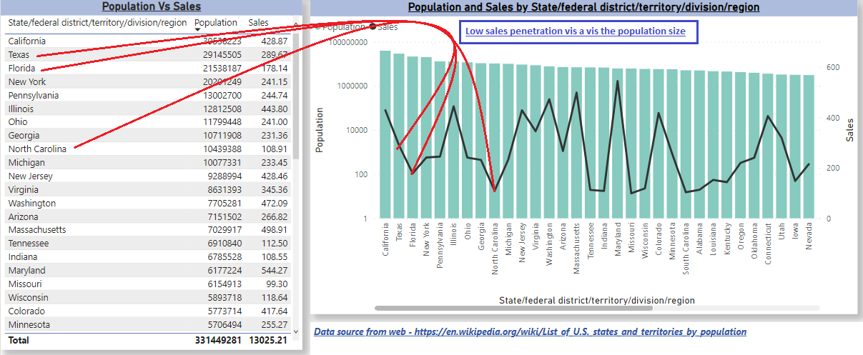

**Final Recommendations**

* A select set of States and Customers can be targeted Item wise, Navigate to the page named “Products>Customers>Locations” and click on the Items – Spring T-Shirt, Cotton Sweater and Leather Bag. Detailed information will be populated in a drill through page named as Target Customers. Even Location wise targeted customers and the targeted products be populated accordingly.

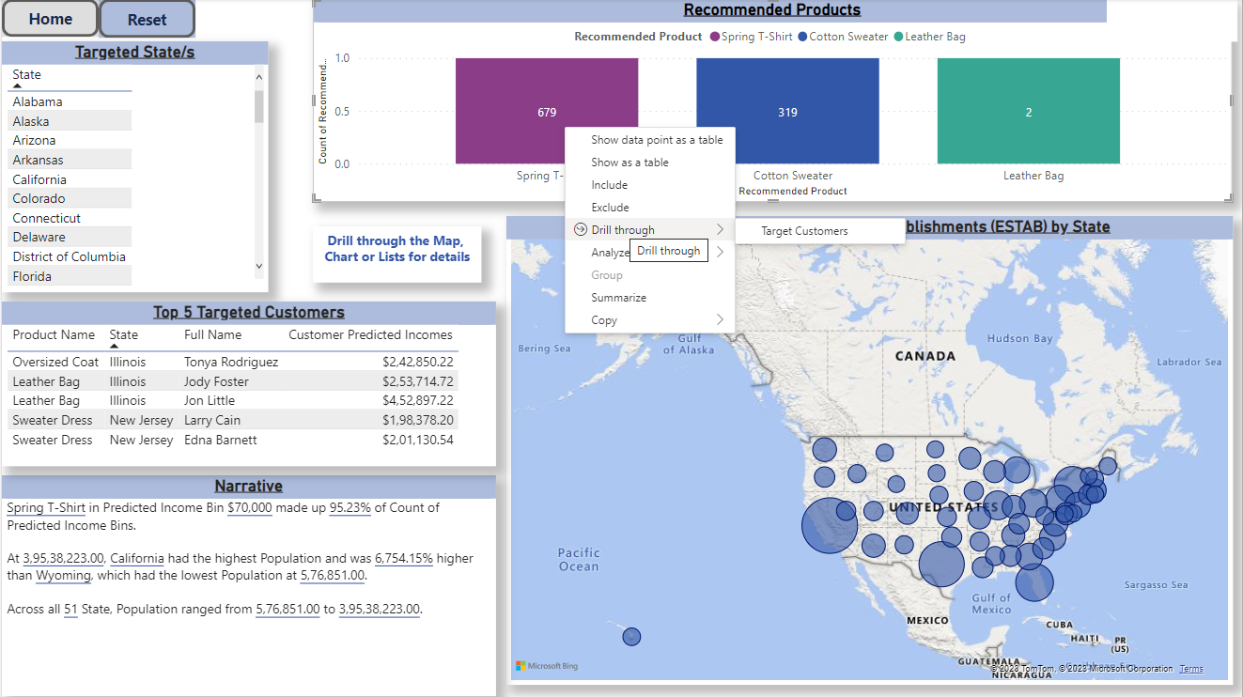

* The histogram on Predicted Income Bins shows a right skew meaning more customers are in the less than $130000 salary range hence the products can accordingly be targeted to them. The correlation between the sales and incomes a strong one

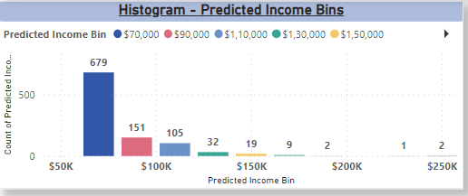

* The Sales trend shows a decline in the last quarter which can be overcome with a targeted approach mentioned above.

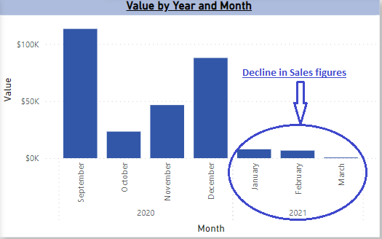

* 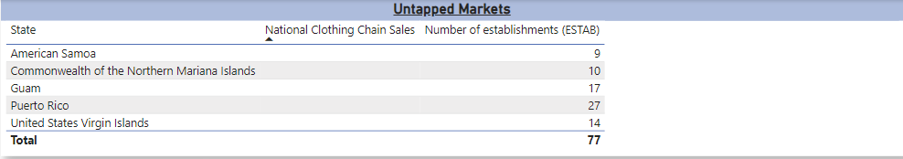There are untapped markets as evidenced in the page named “Untapped Markets” where National Clothing chain has no presence. The population vs sales chart also shows disproportionate sales trends state wise. A statewise targeted approach can be taken up for the opening up of more establishments keeping in mind the findings from the targeted customers and location findings as per the page named “Products>Customers>Locations”.
* The Customer Ratings to the Return rates have a moderate correlation hence the quality of the products needs to be improvised in order to the get the targeted average customer ratings of 4 stars in the coming year. This is currently averaging on 3.79 stars.

